Multiple-choice section – choose the correct answer

Question 1 [1.4]

If the tax-free threshold is $6000 and the tax from $6000–$37 000 is 15c for each $1 over $6000, then the tax payable on $28 500 is closest to:

A $3375 B $4275 C $465 D $5550

Question 2 [1.5]

If *I* = $45.62, *r* = 9.2% simple interest, *T* = 26 months, the principal to the nearest $ would be:

A $109 B $194 C $228 D $229

Question 3 [2.1]

Which one of the following sets of side lengths belongs to a right-angled triangle?

A 4, 9.6, 10 B 4, 4.3, 5.9 C 4, 5, 6 D 4, 7.5, 8.5

Question 4 [2.3]

A right-angled triangle has a hypotenuse of 14.64 m and a second side of 9.72 m. What is the length of the third side, correct to 2 decimal places?

A 10.94 m B 10.94 m C 17.57 m D 308.81 m

Question 5 [2.4]

A direct diagonal path across a rectangular park 250 m long and 180 m wide is closed while it is being repaired. How much further, to the nearest metre, does a person have to walk if they use the footpath around the perimeter of the rectangle to reach the opposite corner?

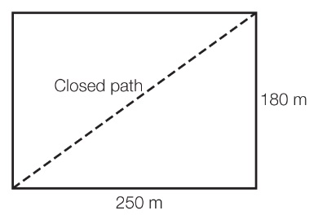

A 122 m B 173 m C 308 m D 430 m

Question 6 [3.3]

The value of 0.023 45 × 0.046 written in scientific notation is:

A 0.001 078 7 B 1.0787 × 10-3 C 1.0787 × 103 D 1078.7

Question 7 [3.6]

When simplified, (6*d* + 5)(6*d* – 5) – (4*d* + 3)(4*d* – 3) is equal to:

A 2*d*2– 342*d*2– 34 B 20*d*2 – 34 C 20*d*2  – 16 D 20*d*2  + 16

Question 8 [4.2]

The area of a circle with a diameter of 13.46 cm is closest to:

A 42.29 cm2 B 142.29 cm2 C 84.57 cm2 D 569.17 cm

Question 9 [4.3]

The surface area of a rectangular prism 3.26 cm × 4.67 cm × 1.39 cm is closest to:

A 18.64 cm2 B 21.16 cm2 C 26.25 cm2 D 52.49 cm2

Question 10 [4.4]

A swimming pool is built in the shape of a trapezoidal prism. It is 25 m long, 12 m wide and is 1.2 m deep at the shallow end and 2.8 m deep at the deep end. The capacity of the pool is closest to:

A 600 L B 600 kL C 1200 kL D 60 000 L

Question 11 [5.1]

The equation 5 – 2*r* = -1 has the solution:

A *r* = -3 B *r* = -2 C *r* = 2 D *r* = 3

Question 12 [5.2]

If *p* = 2*rx – q*, which of the following equations is incorrect?

A *x* =  B *r* = C *x* =  D *q* =2*rx – p*

Question 13 [5.5]

The gradient of the line with equation 3*y* + 4*x* = -6 is:

A -6 B **** C **** D 4

Question 14 [5.6]

The coordinates of two points that lie on the line 5*y* = 2*x* − 10 are:

A (5, 0) and (0, -2) B (5, 0) and (0, 2) C (-5, 0) and (0, 2) D (5, 0) and (0, -2)

Question 15 [6.3]

Which statement is false?

A A square is a special rectangle. B A rhombus is a special kite.

C A rectangle is a special kite. D A square is a special rhombus.

Question 16 [6.6]

The diagram shows two similar triangles. The equation used to find *x* is:

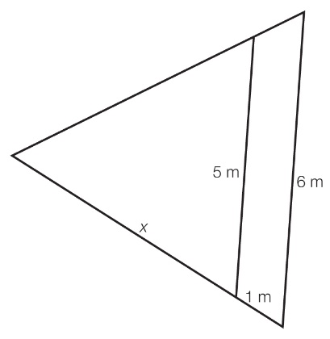

A  B  C  D 

Question 17 [6.7]

Which of the following could not be a net for a cube?

|  |  |
| --- | --- |
| A  ACPM9_PR_1_03teoy | B  ACPM9_PR_1_04teoy |
| C  **ACPM9_PR_1_05teoy** | D  **ACPM9_PR_1_06teoy** |

Question 18 [7.2]

The value for cos(34°) is the same as that of:

A sin(56°) B sin(34°) C tan(56°) D cos(56°)

Question 19 [7.3]

The value of *m* in this diagramcould be found by using the equation:

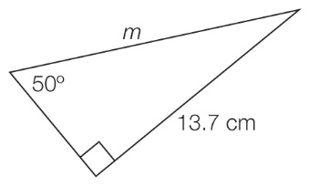

A *m* =  B *m* = C *m* =13.7 sin(50°) D *m* =

Question 20 [8.2]

To complete a survey on voting intentions, pollsters need to select a random sample. This is best done by:

A randomly selecting people at a supermarket

B randomly selecting people attending a football match

C randomly selecting people from the phone book

D randomly selecting people from the electoral roll.

Question 21 [8.6]

In a group of 20 people, 10 people play tennis, 8 people play golf and 4 people play neither tennis nor golf. The probability that a person selected at random from the group only plays tennis is:

A  B  C  D 

Question 22 [9.1]

Which of the following equations shows a quadratic relationship?

A *y* = *x*2 – 8*x* – 9 B *y*2 = *x* + 1 C *y*2 = *x*2 – 11 D *y*2 = 5 – *x*2

Question 23 [9.4]

What are the centre coordinates and radius of the circle with equation (*x* + 4)2 + (*y* – 7)2 = 64?

A (4, -7), 8 B (-4, 7), 8 C (-4, 7), 64 D (4, -7), 64

Question 24 [9.5]

A graph of an exponential with equation *y* = 2*x* is shifted 8 units left and 7 units down. Which of the following is the equation of the new graph?

A *y* = 2*x* – 8 + 7 B *y* = 2*x* + 8 + 7 C *y* = 2*x* – 8 – 7 D *y* = 2*x* + 8 – 7

Question 25 [9.7]

The volume *V* of water in a tank that is filling is directly proportional to time *t*.   
This may be written as:

A ** B ** C ** D **

Multiple-choice results: \_\_\_ / 25

Short answer section

Question 26 4 marks [1.1]

Calculate the increased/decreased amount for the following, rounding your answer to the nearest cent.

**(a)** a 16.3% increase in sales of $4326

**(b)** a 2.58% decrease in a price of $3.98

Question 27 4 marks [2.2]

Find *x* in the triangle shown, giving your answer:

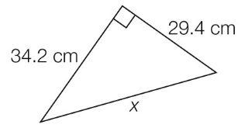

**(a)** in exact (surd) form

**(b)** as a rational approximation correct to 2 decimal places.

Question 28 3 marks [3.1]

Simplify (*x*2*y*)5 × *x*6*y*.

Question 29 6 marks [3.2]

Simplify , leaving your answer with positive indices.

Question 30 6 marks [3.4]

Rearrange the formula  to make *x* the subject.

Question 31 4 marks [3.5]

Expand the following and simplify.

(a) (*c* – 8)(*c* – 6)

(b) (2*m* + 4)(3*m* – 7)

Question 32 4 marks [3.6]

Expand each of the following using a perfect square rule.

(a) (2*a* + *b*)2

(b) (*x –* 3*y*)2

Question 33 3 marks [3.6]

Expand each of the following using the difference of two squares rule.

(a) (*m* – *n*)(*m* + *n*)

(b) (6*p* + 7*r*)(6*p* – 7*r*)

Question 34 2 marks [3.7]

Factorise using common factors.

(a) 4*p2 –* 4*p*

(b) *-*3*c2d* – 9*c3*

Question 35 2 marks [3.8]

Factorise the following by grouping in pairs.

(a) *cd* – *bc* + 3*d* – 3*b*

(b) *v*2 – 6*v* – 5*v* + 30

Question 36 4 marks [4.1]

Find the perimeter of the following shapes. Give your answer correct to 2 decimal places.

(a)

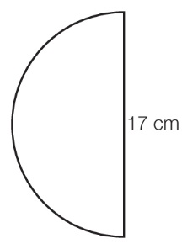

(b)

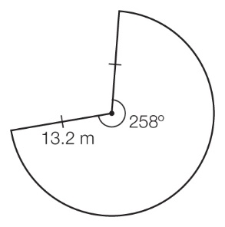

Question 37 4 marks [4.2]

Find the shaded area of the following shape, correct to 2 decimal places.

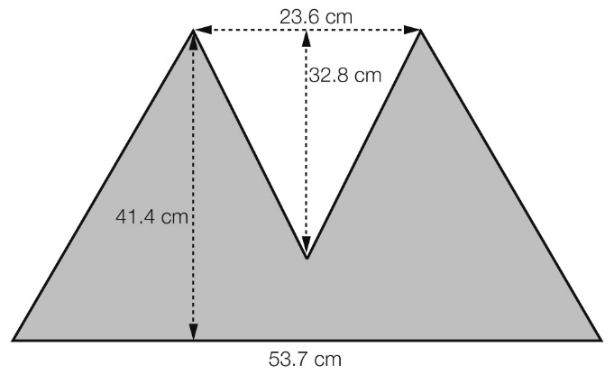

Question 38 4 marks [4.4]

Find the volume of the following solid. Give your answer correct to 2 decimal places.

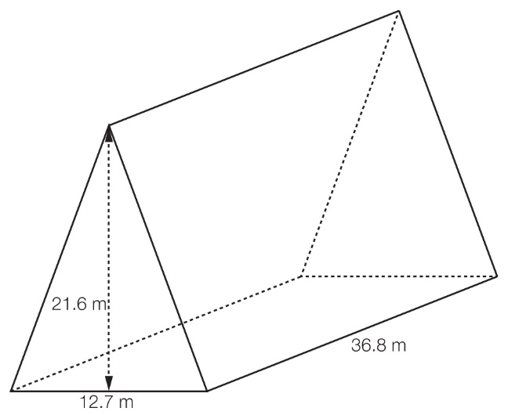

Question 39 2 marks [5.1]

Solve the following linear equations. Check your answer by substitution.

(a) 4*x* – 7 = 5 – 2*x*

(b) 

Question 40 5 marks [5.3]

Find the distance between (2, -3) and (-4, 5).

Question 41 5 marks [5.3]

Complete the table of values below, then plot the graph of *y* = 4 – 2*x* for -3 ≤ *x* ≤ 3.

|  |  |  |  |  |  |  |  |
| --- | --- | --- | --- | --- | --- | --- | --- |
| *x* | -3 | -2 | -1 | 0 | 1 | 2 | 3 |
| *y* |  |  |  |  |  |  |  |

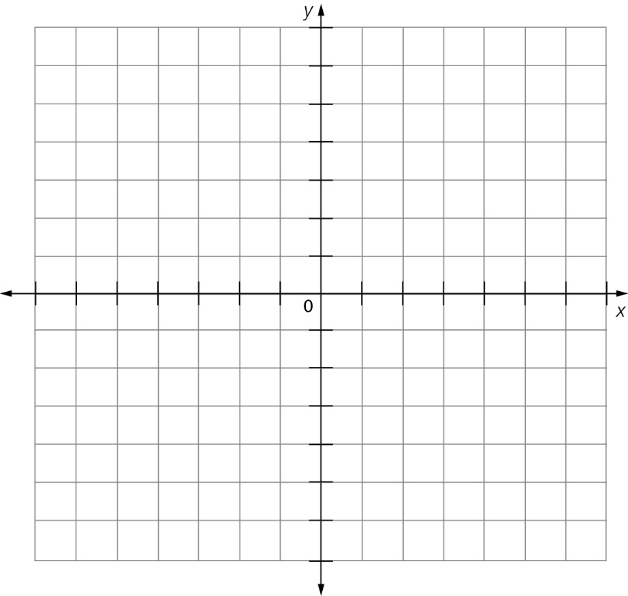

Question 42 3 marks [5.6]

Sketch the graph of *y* = -3*x* using the gradient and *y*-intercept.



Question 43 3 marks [5.8]

Sketch the graph of *y* + 1 = 0.



Question 44 4 marks [6.1]

Find the value of *x* in the diagram shown. Give reasons for your answer.

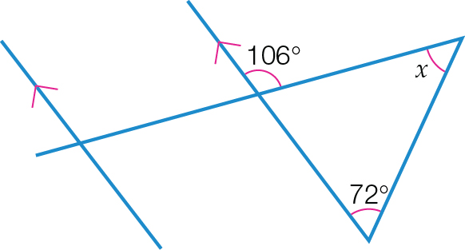

Question 45 2 marks [6.3]

Find the value of the variable in the following figure.

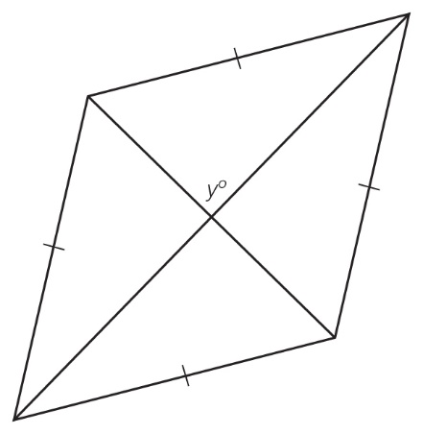

Question 46 7 marks [6.6]

In the diagram below, show that the two triangles are similar and then find the value of the variable.

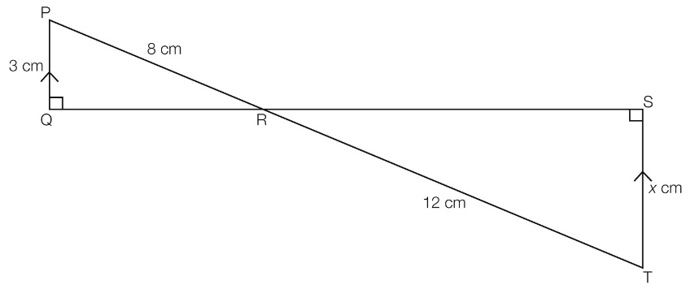

Question 47 3 marks [7.1]

For the triangle below, state the length of the following, correct to 2 decimal places:

**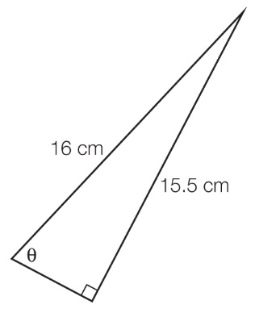**

(a) hypotenuse

(b) opposite side

(c) adjacent side.

Question 48 3 marks [7.3]

Find the value of *x*, correct to 2 decimal places.

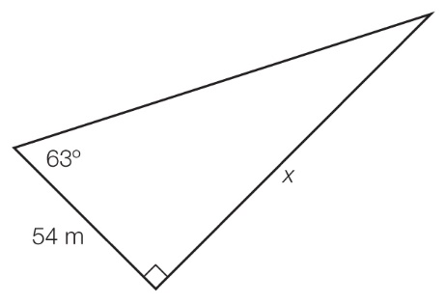

Question 49 3 marks [7.4]

A 5 m ladder leaning against a wall reaches the bottom of a window at a height of 4.2 m above level ground. What angle to the nearest degree does the ladder make with the wall?

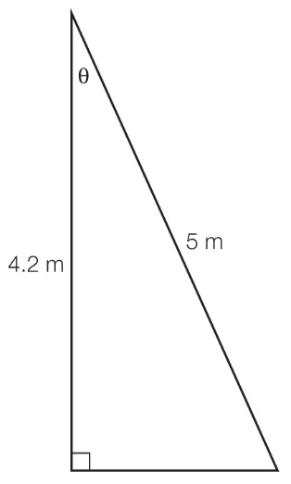

Question 50 6 marks [8.5]

A standard six-sided die is rolled. Find the probability of the roll giving:

(a) a 6

(b) an even number

(c) a number less than 5

(d) a number between 3 and 6

(e) either a 1 or a 2

(f) a number that is not less than 3.

Question 51 6 marks [9.2]

Solve the following quadratic equations using the null factor law.

(a) *x*2 *–* 3*x* = 0

(b) 5*x*2 – 45 = 0

Question 52 3 marks [9.3]

For the quadratic relationship *y* = (*x* – 3)2 *–* 4:

(a) state the transformations of *y = x*2 that have taken place

(b) find the turning point.

Question 53 3 marks [9.4]

Determine the centre and radius of the following circle relationship and hence the equation of the circle.

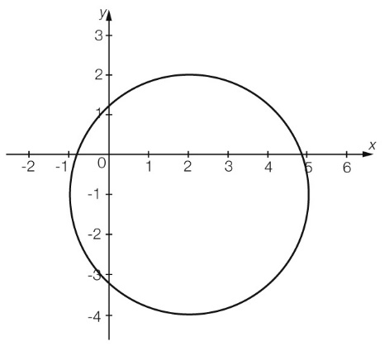

Question 54 2 marks [9.6]

(a) For the following table of values, find the constant of proportionality and hence find the missing value in the table.

|  |  |  |  |  |
| --- | --- | --- | --- | --- |
| *x* | 0 | 3 | 5 | 9 |
| *y* | 0 | 12 | 20 |  |

(b) Write the equation of the relationship between the variables.

Short answer results: \_\_\_ / 110

Extended answer section

Question 55 8 marks [1.7]

Water is supplied to a household with five family members by ‘Pure Blue Water’ at the rate of $1.197/kL for the first 39 500 L and $1.37/kL for water used in excess of 39 500 L. During one quarter, the water usage was 62 287 L. There was also a sewage charge of $54.32, a service charge of $81.44, a drainage charge of $21.36 and an annual Parks and Gardens levy of $85.32.

(a) What was the total bill for the quarter?

(b) What was the daily water usage per person for a 91-day billing period? Give your answer in litres correct to 2 decimal places.

(c) What was the cost of water used per person per day during this quarter? Give your answer in cents correct to the nearest cent.

Question 56 8 marks [2.4]

Find the unknown lengths in the following diagram, giving your answers as rational approximations correct to 2 decimal places.

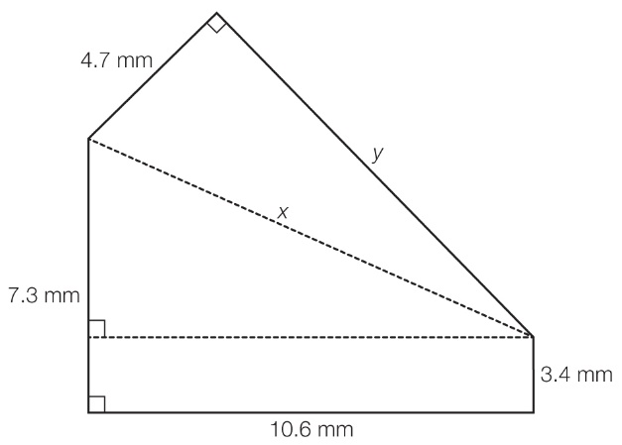

Question 57 14 marks [5.5]

(a) Given the points *A*(-2, 8), *B*(1, 11), *C*(8, 11) and *D*(-2, 1), find the gradients of the lines *AB*, *BC*, *CD* and *DA.*

(b) Explain why the shape formed by joining these four points in the order of A→B→C→D is a trapezium.

(c) Which line is vertical? Justify your answer.

(d) Which line is horizontal? Justify your answer.

Question 58 6 marks [8.4]

40 students were asked how many hours a week they played sport and the results were tabulated.

|  |  |  |  |  |  |  |  |
| --- | --- | --- | --- | --- | --- | --- | --- |
| 12 | 12 | 8 | 3 | 2 | 2 | 6 | 7 |
| 3 | 1 | 4 | 9 | 40 | 0 | 3 | 0 |
| 5 | 32 | 2 | 1 | 17 | 3 | 8 | 2 |
| 0 | 4 | 18 | 2 | 5 | 5 | 3 | 7 |
| 12 | 9 | 15 | 40 | 12 | 2 | 14 | 2 |

A second group of 40 students were surveyed and their results were also tabulated.

|  |  |  |  |  |  |  |  |
| --- | --- | --- | --- | --- | --- | --- | --- |
| 33 | 9 | 22 | 3 | 4 | 2 | 3 | 21 |
| 29 | 2 | 8 | 5 | 8 | 2 | 4 | 9 |
| 14 | 3 | 3 | 2 | 14 | 5 | 3 | 15 |
| 17 | 5 | 2 | 10 | 4 | 10 | 4 | 0 |
| 5 | 1 | 40 | 10 | 9 | 8 | 4 | 18 |

Use back-to-back stem-and-leaf plots to compare these two samples.

Question 59 4 marks [9.5]

Sketch the graph of *y* = 2*x* – 1.

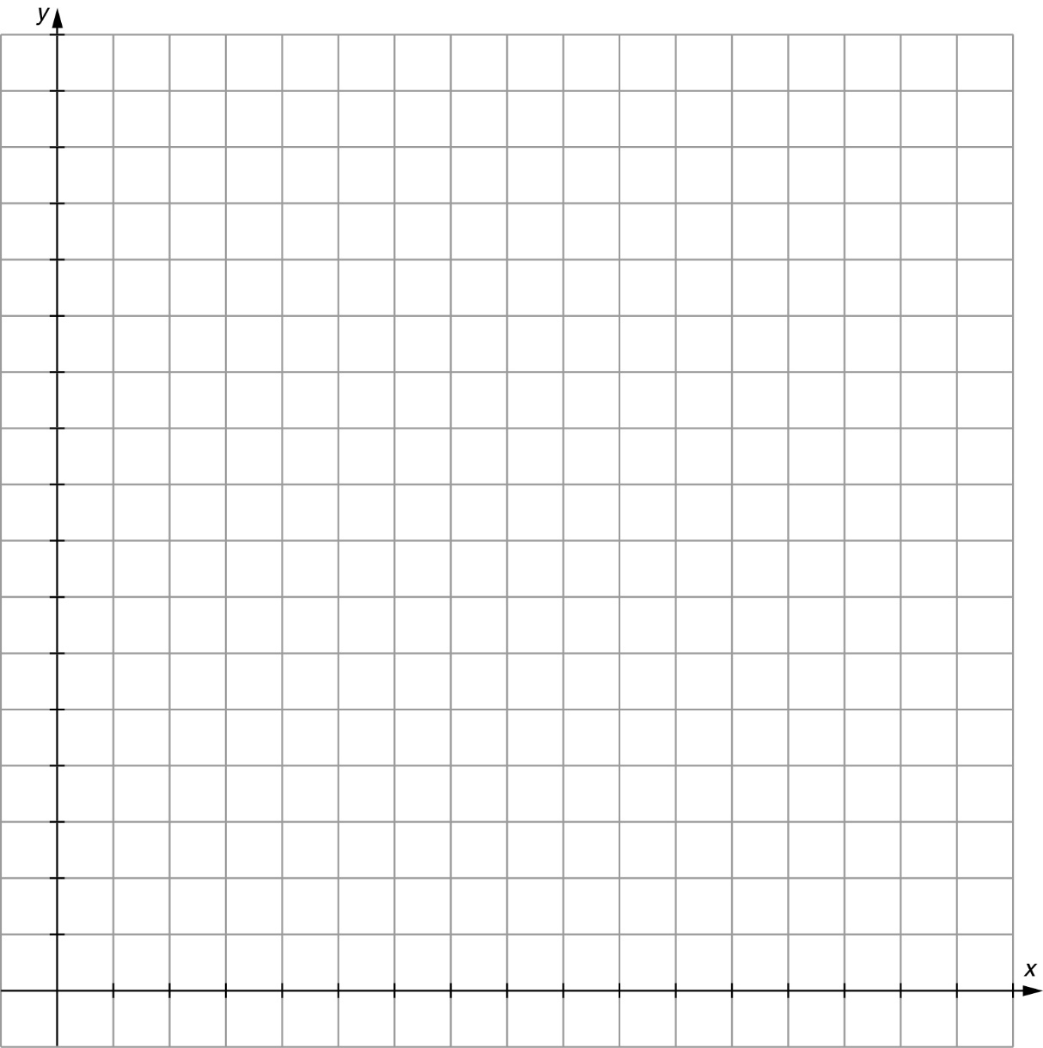

Extended answer results: \_\_\_ / 40

TOTAL test results: \_\_\_ / 130